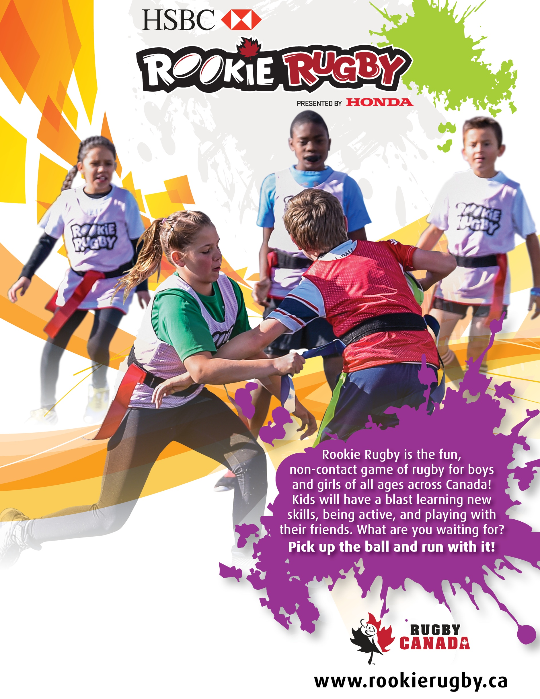

**Text can be placed in this area.**

**Text can be placed in this area.**

**Text can be placed in this area.**

**Text can be placed in this area.**

**Text can be placed in this area.**

**Text can be placed in this area.**

**Text can be placed in this area.**

**Text can be placed in this area.**

**Text can be placed in this area.**

**Text can be placed in this area.**

Rookie Rugby is the fun,

non-contact game of rugby for boys and girls of all ages across Canada! Kids will have a blast learning new skills, being active, and playing with

their friends. What are you waiting for?

**Pick up the ball and run with it!**